**Control Flow and Built in Data Structures**

Q1)Write a code to filter all sub-strings which has even number of vowel?

example Input:

"I have an input string which contains even and odd numbers of vowels aA aa aaa ae aeo”

output:

I

an

string

which

contains

and

odd

of

aaa

aeo

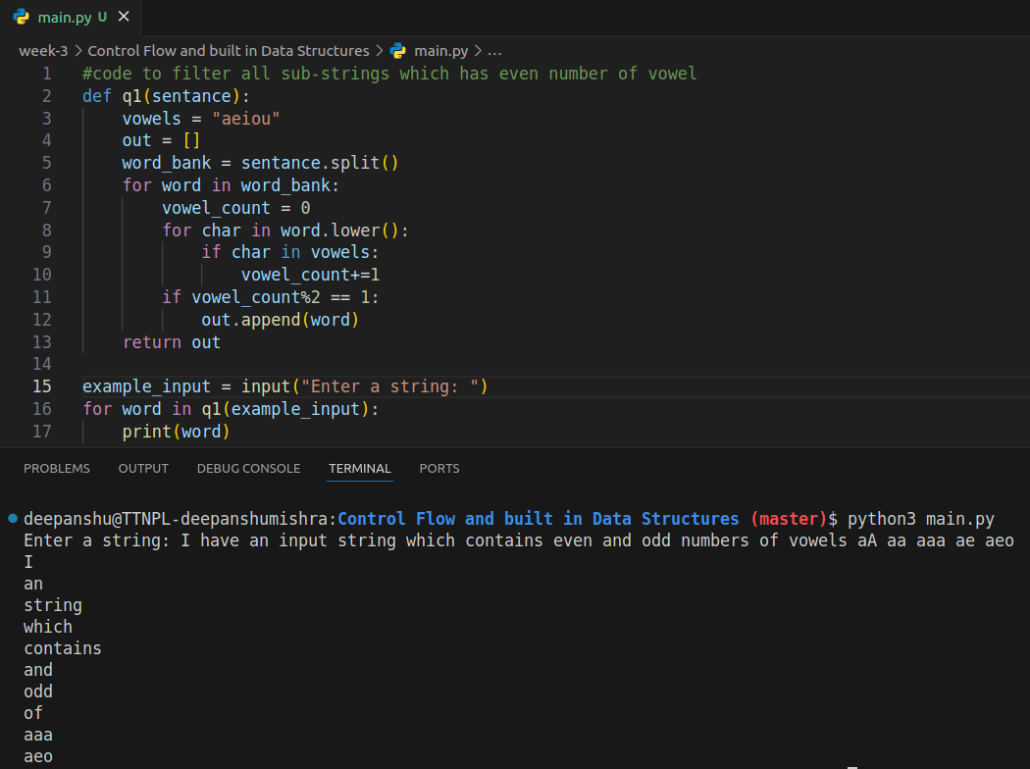

Q2)Programing: From a multi-words and multi-line string, prepare a dict with key as "word" and value as occureance of word.

Example Input: astring = """Python Multiline String Using Triple-Quotes

Using the triple quotes style is one of the easiest and most common ways to split a large string into a multiline Python string. Triple quotes (''' or \""") can be used to create a multiline string. It allows you to format text over many lines and include line breaks. Put two triple quotes around the multiline Python string, one at the start and one at the end, to define it."""

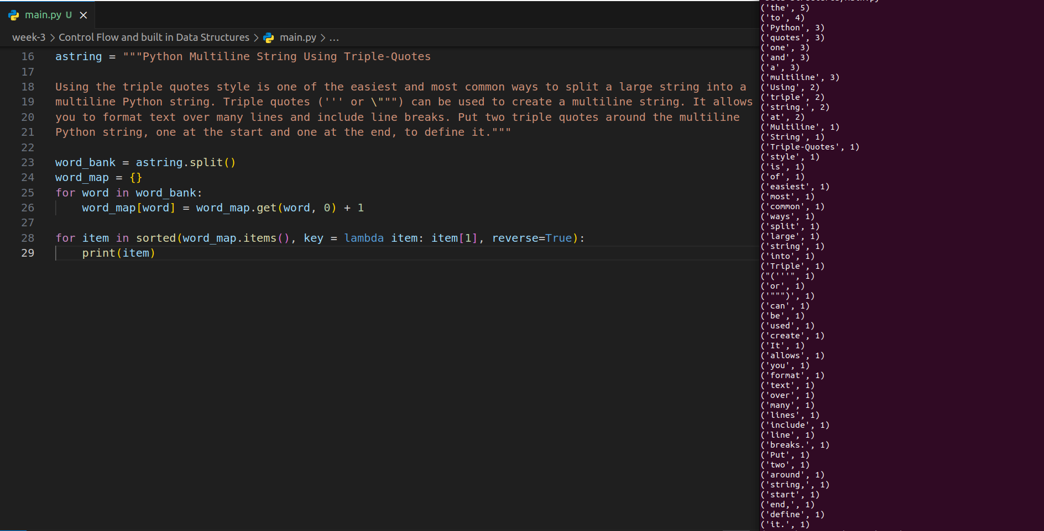

(output in terminal next to the code because big)

Q3)Programing: From a multi-words and multi-line string, prepare a filter the list of words which have multiple occurances in string.

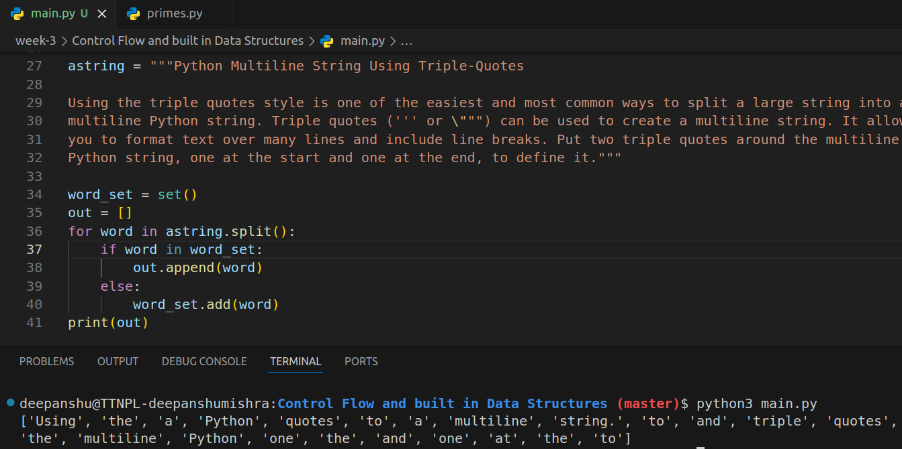

Q4)From a multi-words and multi-line string, display list of words and word's length with occurance more than 1 in sorted order

